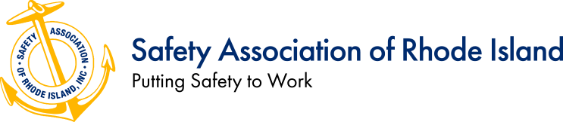

Association Fact Sheet
Mission:
The Safety Association of Rhode Island, Inc. (also known as SARI) is organized to bring to its members national viewpoints and local expertise in the fields of safety, occupational health, and environmental management. We welcome members from Rhode Island and nearby Massachusetts and Connecticut.

Our membership includes a diverse group of safety, health and environmental professionals who share their insights and experiences with fellow members.
The exchange of information and ideas between members provides a unique opportunity to work together to address and solve the safety challenges facing business and industry today. SARI is a non-profit organization serving the safety, occupational health and environmental community since 1949.

What do we do?
- Plan, organize and execute quarterly networking meetings/presentations focused on timely safety, health & environmental topics of benefit to all members and non-members.
- Promote and review submissions for the SARI Safe Employer Award Program.
- Promote and review applications for the SARI Scholarship (up to $500).
- Post relevant safety information and provide resources through the SARI website.
- Solicit speakers for relevant safety presentations at quarterly meetings and organize facility tours.

2021-2022 Board of Directors
President | Vice President |  | Secretary | Treasurer
Deidra Tart, CPM  Business Development Specialist  Rise Engineering | John Bernardo  EHS Manager  First Choice Safety Solutions, LLC |  | Shannon Earle  Safety & Security Manager  The Town Dock | Johnell Norton  EHS Manager (Ret.)  Teknor Apex Co.
Past President | Sergeant at Arms |  | Program Chairman | Assistant Treasurer
Peter Turner, CSP, ASP  Manager Safety & Risk, Northeast  Cox Communications | Paul Simpson  Safety Saves, LLC |  | John Lynch  Safety Manager  North-Eastern Tree Service Inc. | Fred Malaby, CIH  FMalaby, LLC.
Members at Large
Jason Lavoie  Safety & Security Coordinator  Toray Plastics (America), Inc. |  | David Aucoin, CSHO  Safety Compliance Coordinator  Narragansett Bay Commission |  | Gerry Marzilli  Safety Coach, LLC
Steven S. Ruscito, MA
Regional Manager – Risk, Safety & Development
Twin River/Tiverton Casinos & Hotels

